CLIENT NAME HERE
Intune – How to Update the INC Agent App Registration Token

PREPARED BY
Kelvin Aruin – Senior Technical Project Engineer

TABLE OF CONTENTS
Get a New Registration Token from INC 3
Update the APP via ICM 5

Get a New Registration Token from INC
- Log in to the appropriate INC instance for your client. (See IT glue for that information if not sure).
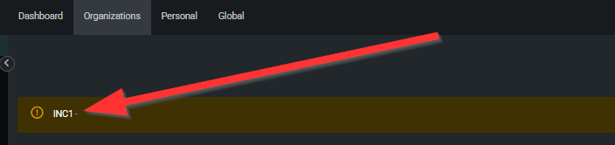
- Navigate to your client in INC.
- Expand the Actions menu on the left hand side and click on ‘Download Agent/Probe’
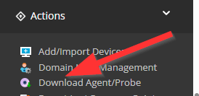
- At the top, click on ‘Get Registration Token’:
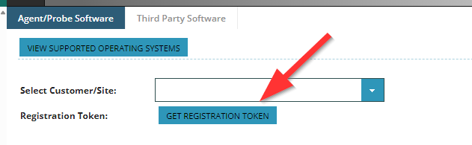

- On the registration token screen, take note of the new token expiration date:
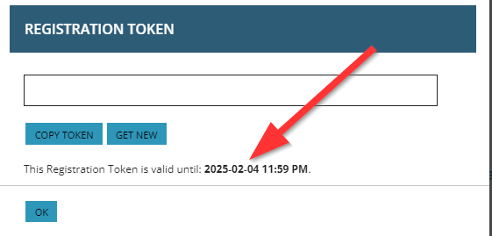
- You will need this date to update the INC App package
- Next, click “Copy Token” as you need this value for the Intune package.
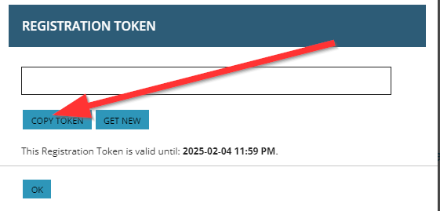
- Save this value as it will be needed for the next step.

Update the INC AGENT APP via ICM
- Login to ICM via https://icm.impactnetworking.com
- Enter the client’s name under accounts:
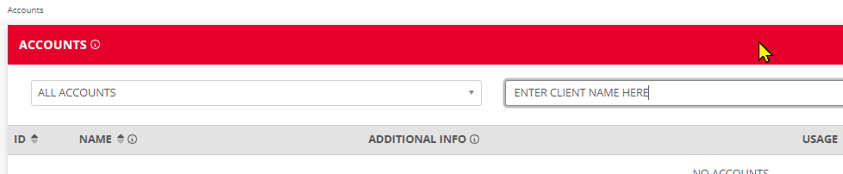
- Click on the client name in the list:
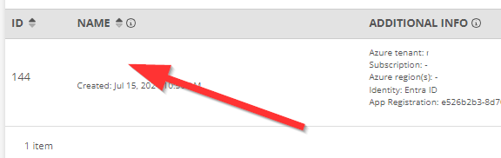

- On the left-hand side navigation menu, click on Intune and then on Apps:
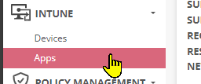
- Locate the INC installation in the list and click on the Name of the application:
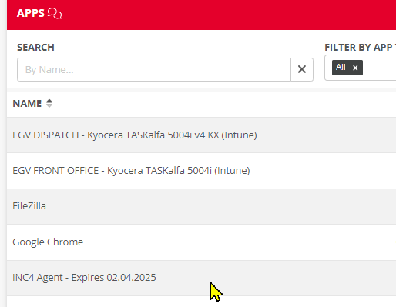
- You will see the Edit App properties window open.
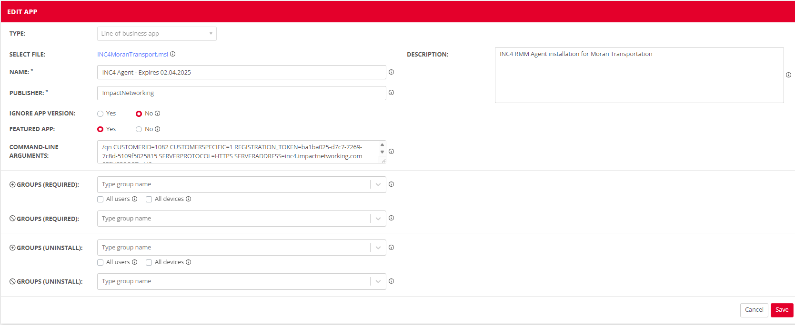
- You will now want to update the “Expires…” date in the Name field. You would have obtained that information in INC.
- Next, replace the REGISTRATION_TOKEN=”” value with the new value you obtained in INC within the ‘Command-line Arguments’ box:
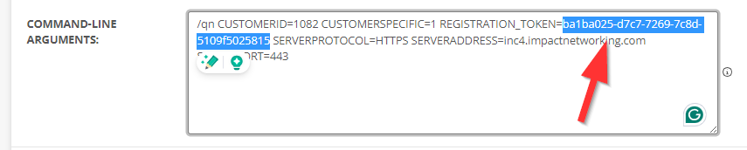
- Once the “NAME” and the “COMMAND-LINE ARGUMENTS” fields have been updated with the new values, simply click on the “Save” button on the bottom right:

- You’re all set!

